   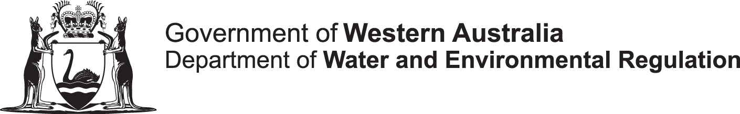  Environmental Protection Act 1986  Section 72 Waste discharge notification | Office use only
Licensing officer
Click here to enter text.
Date received
Click here to enter text.
Accepted as complete
Click here to enter text.
Department reference
Click here to enter text.

To: Chief Executive Officer  Attention: Click here to enter text.  Telephone notification to 1300 784 782 | Department of Water and Environmental Regulation  Locked Bag 10  JOONDALUP WA 6919

Discharge of waste from: | ☐ premises ☐ vehicle  Name of premises/vehicle: Click here to enter text.  Town/suburb: Click here to enter text.
The following notification and information is provided in accordance with s 72 (1) of the Environmental Protection Act 1986 (EP Act):
Licence or works approval number | (If applicable, type in your EP Act licence or works approval number.)
Relevant condition | (If this notification is a requirement under a licence, works approval or pollution abatement notice, type in the relevant condition or measure.)
Description of operation or equipment | (If any of the above two blocks were not filled, please type a brief description of your operation and/or the equipment that malfunctioned.)
Description of incident | (Describe the cause of waste discharge.)
Prescribed details of discharge of waste under regulation 5K of the Environmental Protection Regulations 1987:
Date of incident: | DD/MM/YY  Time: Click here to enter text. Choose an item.
Address/location: | ☐ Map attached of the premises to this notification showing the location of the discharge and the impacted area
Name of person responsible for discharge of waste | (Name of person operating the equipment that resulted in, or otherwise responsible for, the discharge of waste.)
Composition of waste | Click here to enter text.
Quantity of waste discharged | Click here to enter text.
Environmental impact | Did the discharge cause pollution?  ☐ Yes ☐ No  (If yes, describe the nature and extent of the pollution or environmental impact.)  ☐ Map attached to this notification indicating discharge point and impacted area
Remedial action | (What action is to be taken to minimise the effect on the environment from the discharge of waste? Who coordinated this action?)
Waste removal | (Is the waste involved to be removed, dispersed, destroyed, disposed of or otherwise dealt with? If so, in what manner and where to?)

Name of reporter: | Click here to enter text.
Job title: | Click here to enter text.
Contact number: | Click here to enter text.
Organisation: | Click here to enter text.
Date: | Click here to enter text.

Please complete this form and attach to an email along with map of discharge point and send the completed form and map to pollutionwatch@dwer.wa.gov.au.

